Merwin Pinto 202100102_7 Practical Q 7
Write program for shopping mall, on purchase of 5 items
if total amount is >1000 but <3000 then 5% discount if total amount is >3000 but <5000 then 10% discount if total amount is >5000 but <7000 then 12% discount if total amount is >7000 then 15% discount if total amount is >10000 then additional voucher of 1000 Rs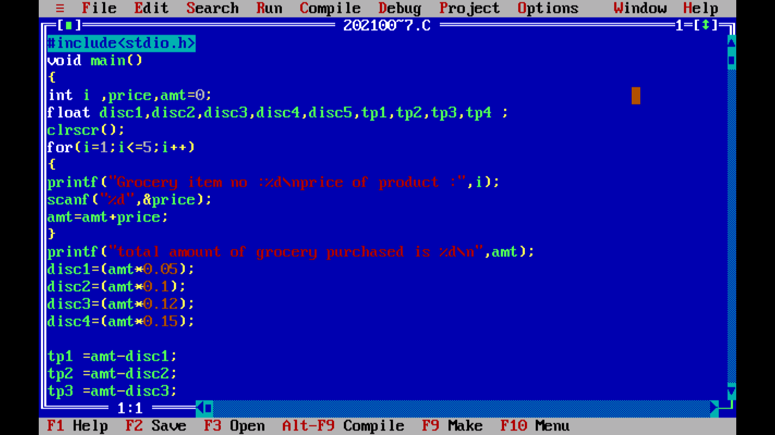
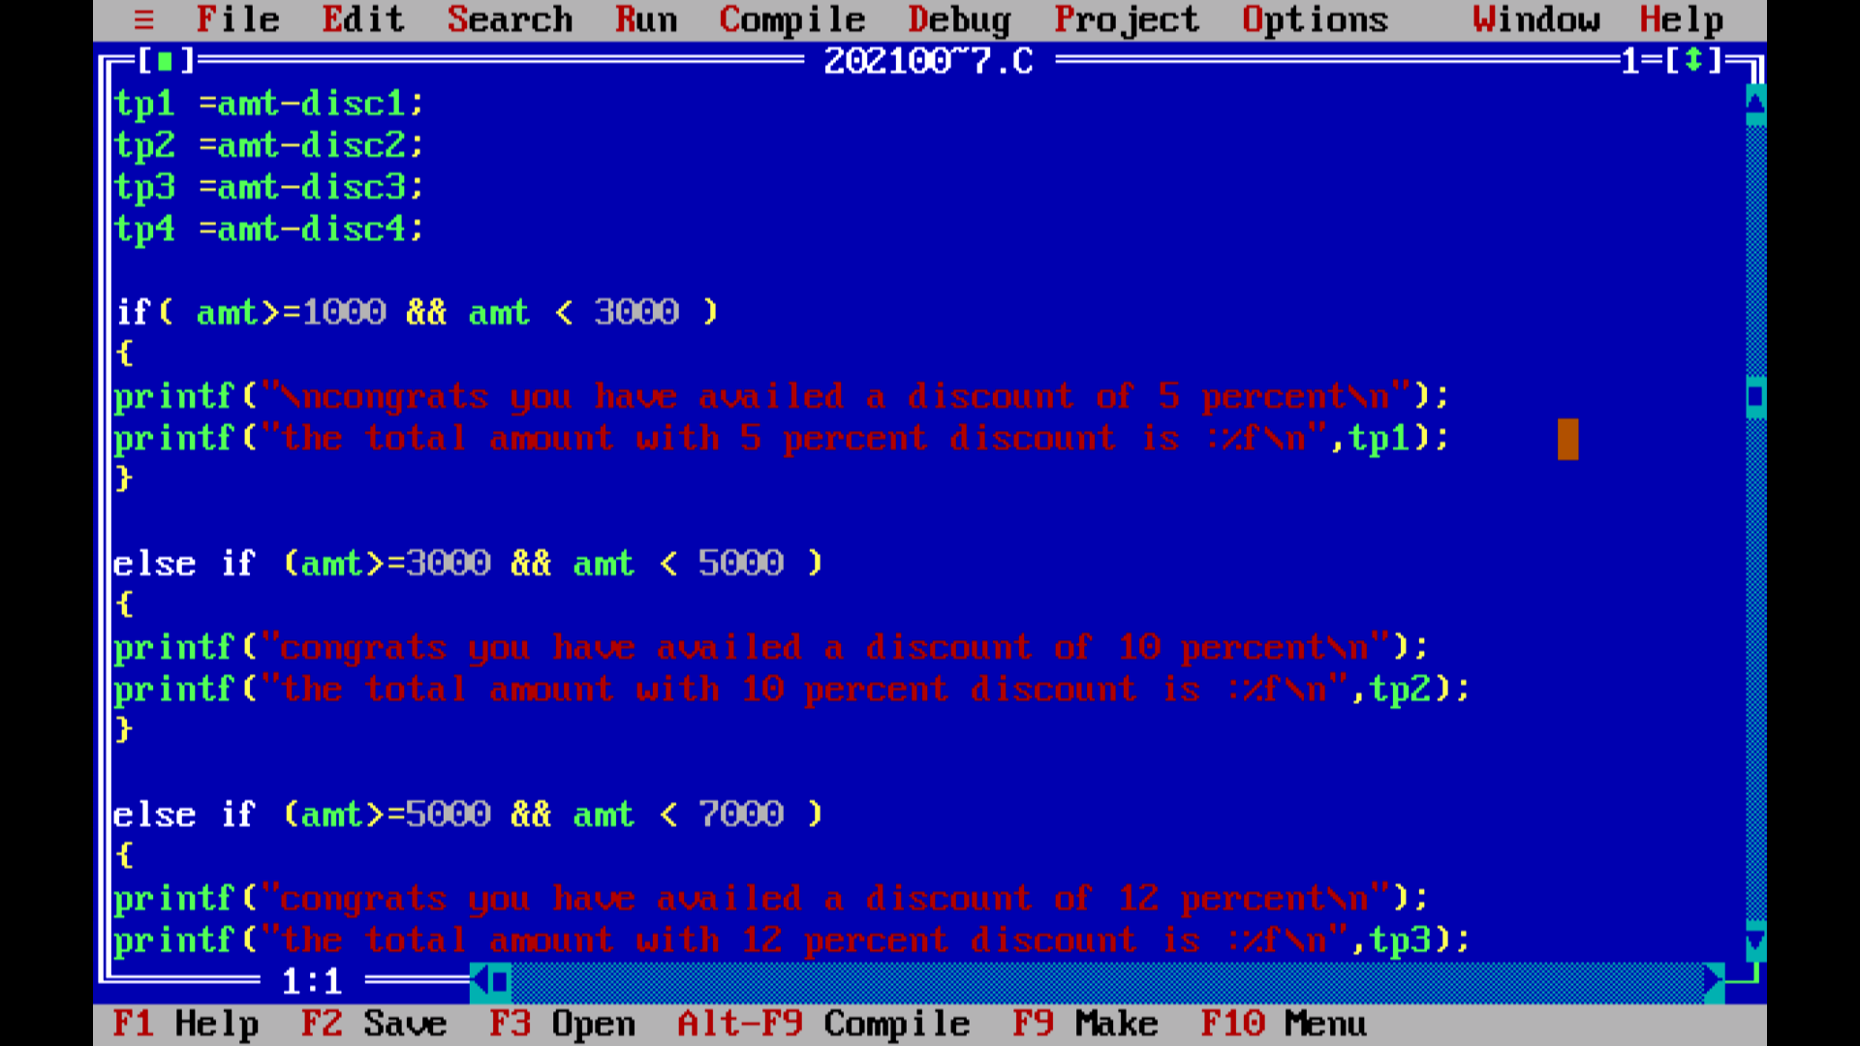
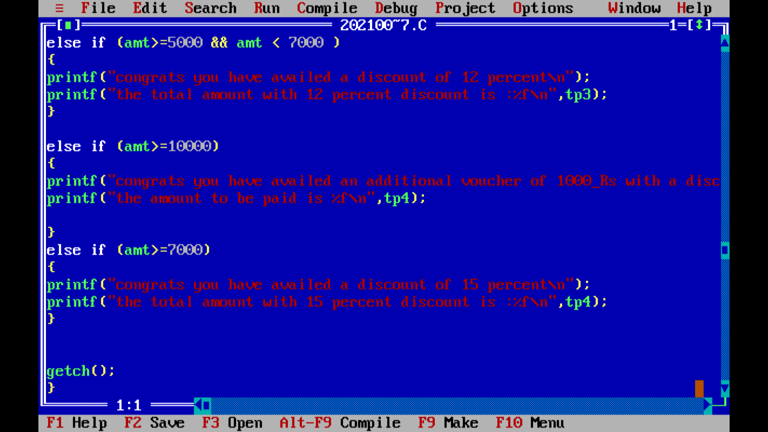
RUNNING THE CODES
5 percent disc
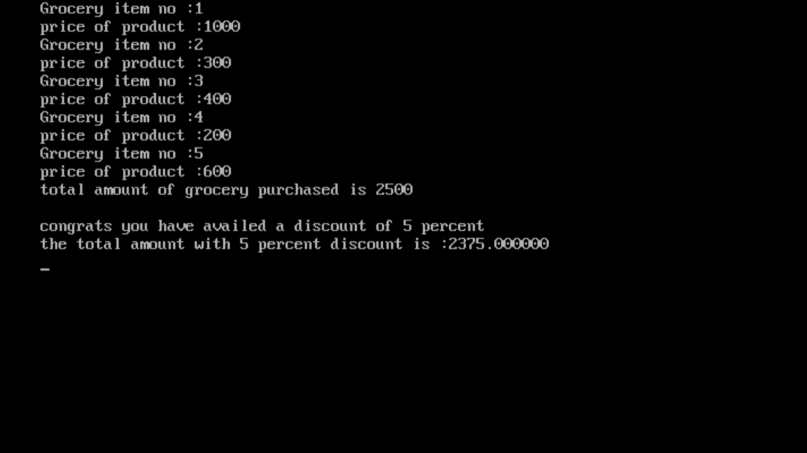

10 percent disc
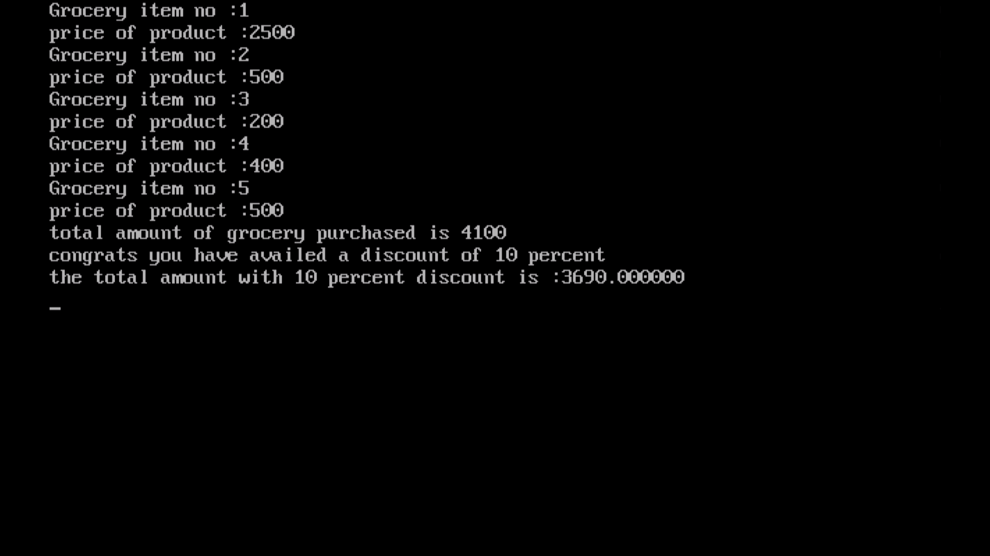

12 percent disc
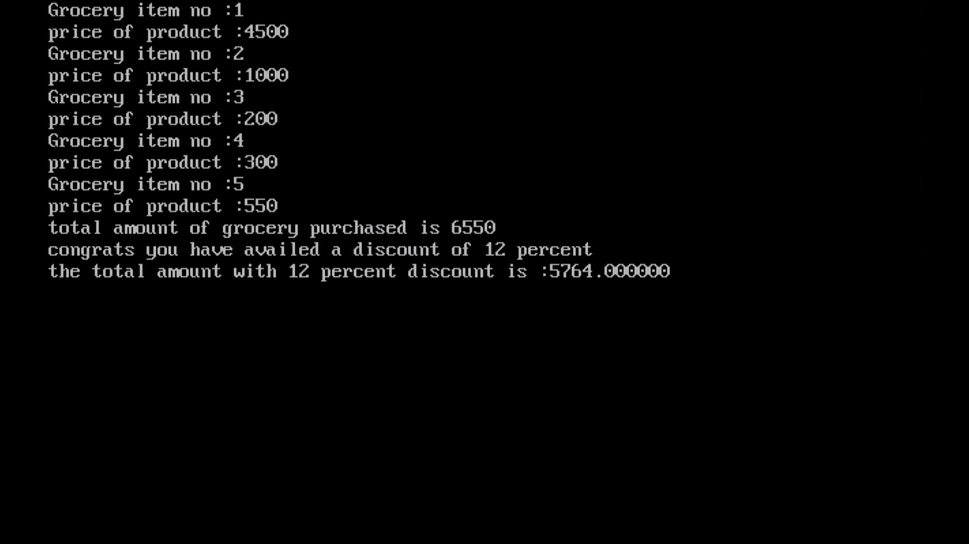

15 Percent Disc
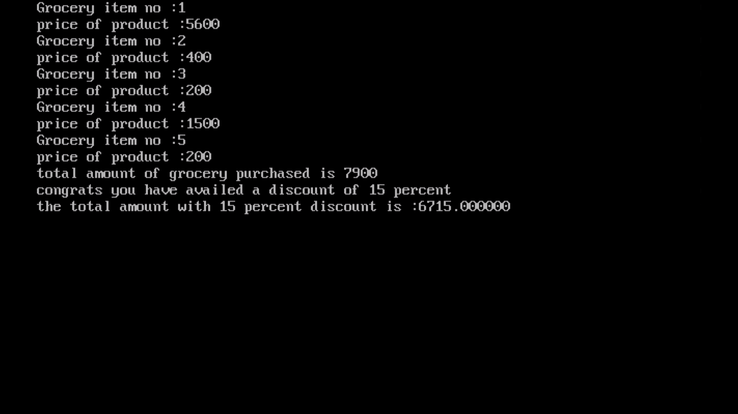
15 percent disc with an additional voucher
